Microsoft Cloud Workshops

Database Upgrade & Migration hackathon

Lab guide

February 2017

© 2016 Microsoft Corporation. All rights reserved. This document is confidential and proprietary to Microsoft. Internal use only. This document is for informational purposes only. MICROSOFT MAKES NO WARRANTIES, EXPRESS OR IMPLIED, IN THIS SUMMARY.

This document is provided "as-is." Information and views expressed in this document, including URL and other Internet website references, may change without notice. You bear the risk of using it.

Some examples are for illustration only and are fictitious. No real association is intended or inferred.

## Contents

Database Upgrade & Migration hackathon 1

Database Upgrade & Migration hackathon answers 19

# Database Upgrade & Migration hackathon

## Overview

World Wide Importers (WWI) has experienced significant growth in the last few years. In addition to predictable growth, they’ve had a substantial amount of growth in the data they store in their data warehouse. Their data warehouse is starting to show its age; slowing down during ETL and during critical queries. It was built on SQL Server 2008 R2 Standard Edition.

The WWI CIO has recently read about new performance enhancements of SQL Server 2016. She is excited about clustered columnstore indexes. In addition, she has chosen to upgrade to Enterprise Edition. She’s hoping that table compression will improve performance, backup time, lessen the load on the Storage Area Network (SAN).

World Wide Importers is concerned about upgrading their database to SQL Server 2016 or Azure SQL DB. The data warehouse has been successful for a long time. As it has grown, it has filled with data, stored procedures, views, and security. World Wide Importers wants assurance that if it moves its data store, it won’t run into any incompatibilities with the storage engine of SQL Server 2016.

She would like a POC of a data warehouse move and proof that the new technology will help ETL and query performance.

## Requirements

* Microsoft Azure subscription must be pay-as-you-go or MSDN.
  + Trial subscriptions will *not* work.
* Local machine or a virtual machine configured with:
  + Remote Desktop Client

## Exercise 0: Deploy your Development Virtual Machine

Duration: 60 minutes

Synopsis: Before attending the hackathon, you should follow these steps to prepare a development virtual machine environment for an efficient day.

### Task 1: Login

* 1. Launch a browser and navigate to https://portal.azure.com. Once prompted, login with your Microsoft Azure credentials. If prompted, choose whether your account is an organization account or just a Microsoft Account.
     1. **Note:** You may need to launch an "in-private" session in your browser if you have multiple Microsoft Accounts.

### Task 2: Create a new virtual machine

1. Click on the **+NEW** link.



1. Select **Compute** in the blade that comes up.
2. In the Compute blade select **See all**.   
     
   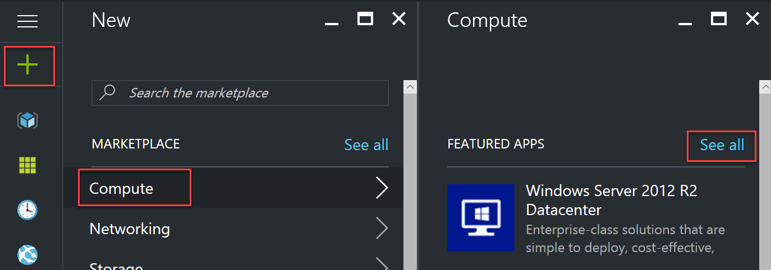
3. This will present the compute related gallery of resources from which you can select a particular image and create an instance.

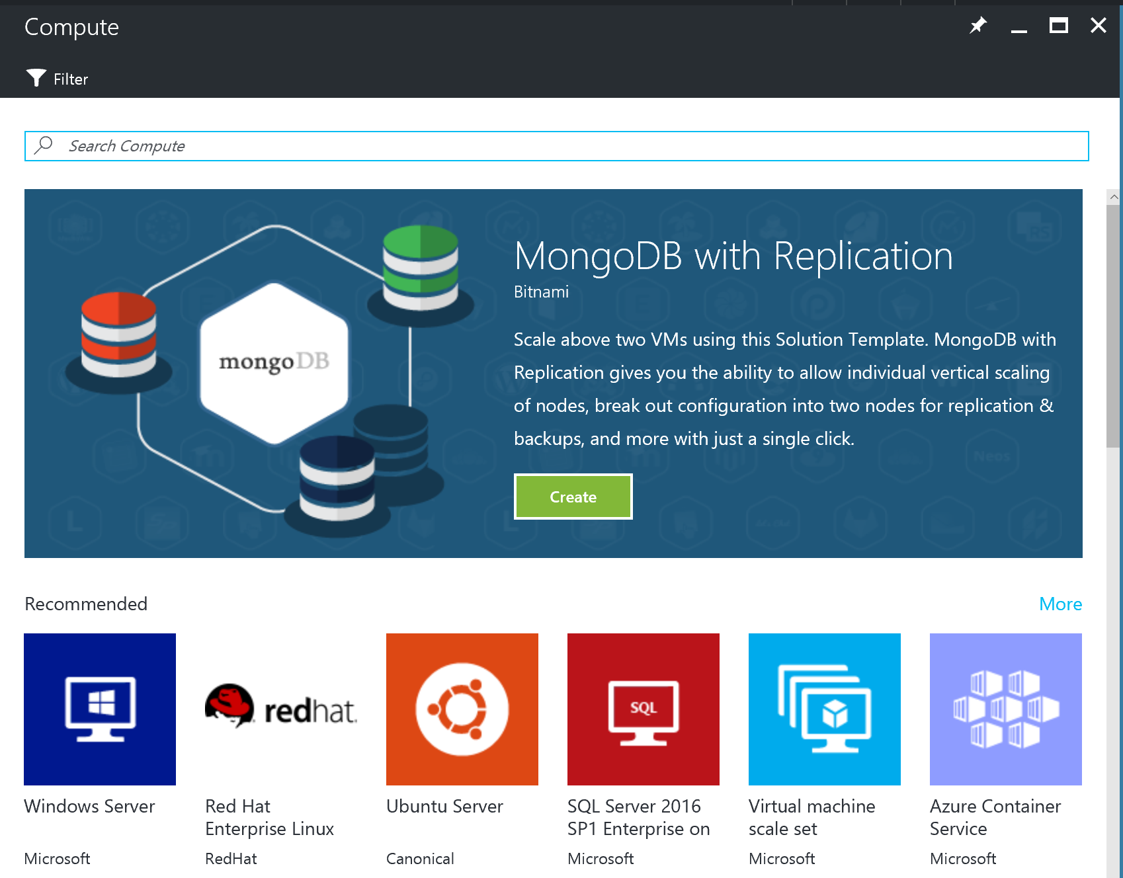

You can use the Search feature to filter the image that you are interested in. Enter **Visual Studio Community 2015** in the search box.

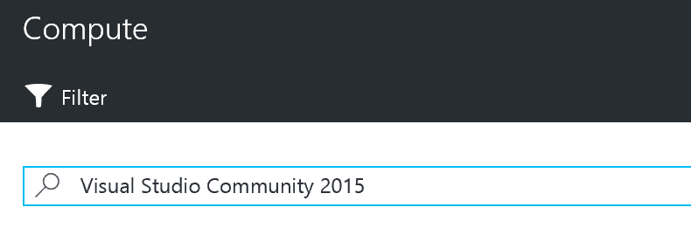

1. Then click on **Visual Studio Community 2015 Update 3 with Azure SDK 2.9 on Windows Server 2012 R2**. 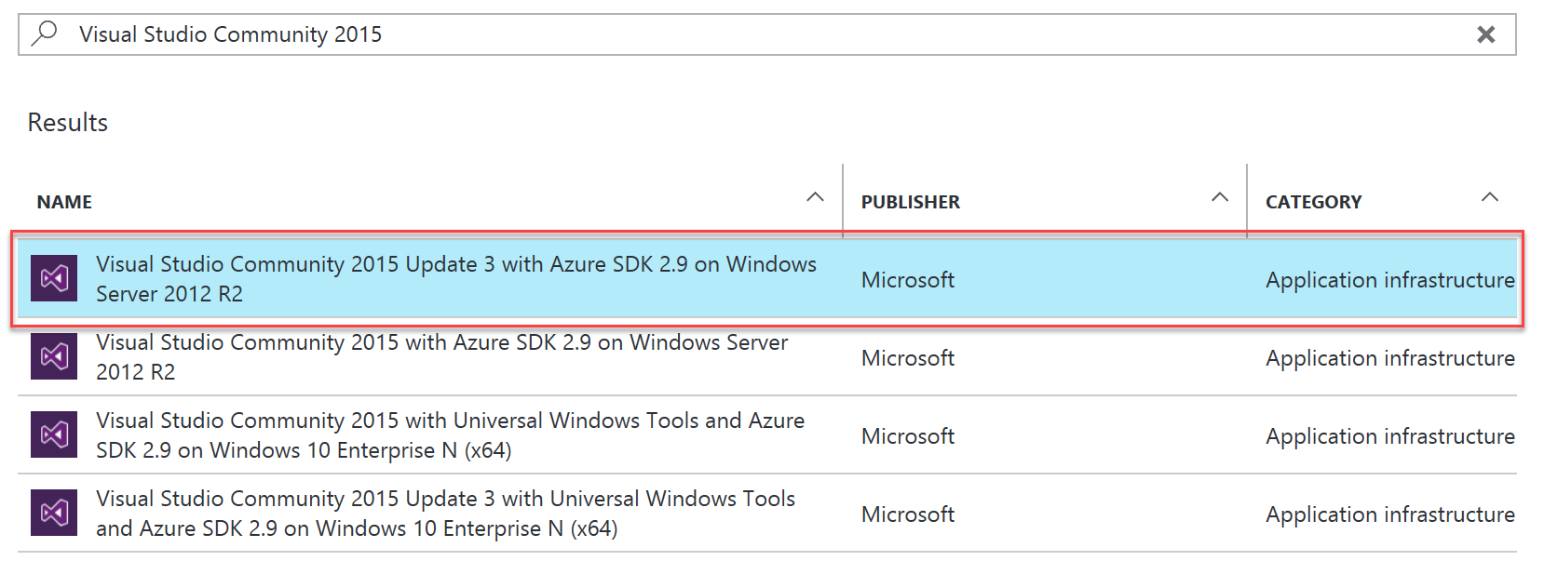
2. In the blade that comes up, at the bottom, ensure the deployment model is set to **Resource Manager** and click **Create**.

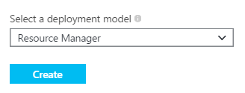

1. Set the following configuration on the Basics tab.

* Name: LABVM
* VM disk type: HDD
* User name: demouser
* Password: demo@pass123
* Subscription: If you have multiple subscriptions choose the subscription to execute your labs in.
* Resource Group: hackathon
* Location: Choose the closest Azure region to you.

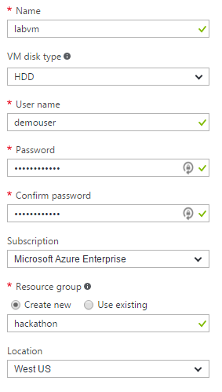

1. Click **OK** to move to the next step.
2. On the Choose a Size blade, click **View all**
3. Choose the instance size on the Size blade. We recommend at a machine with at least 7 GB of RAM to accommodate Visual Studio, so a **DS2 V2** standard is a good baseline option.

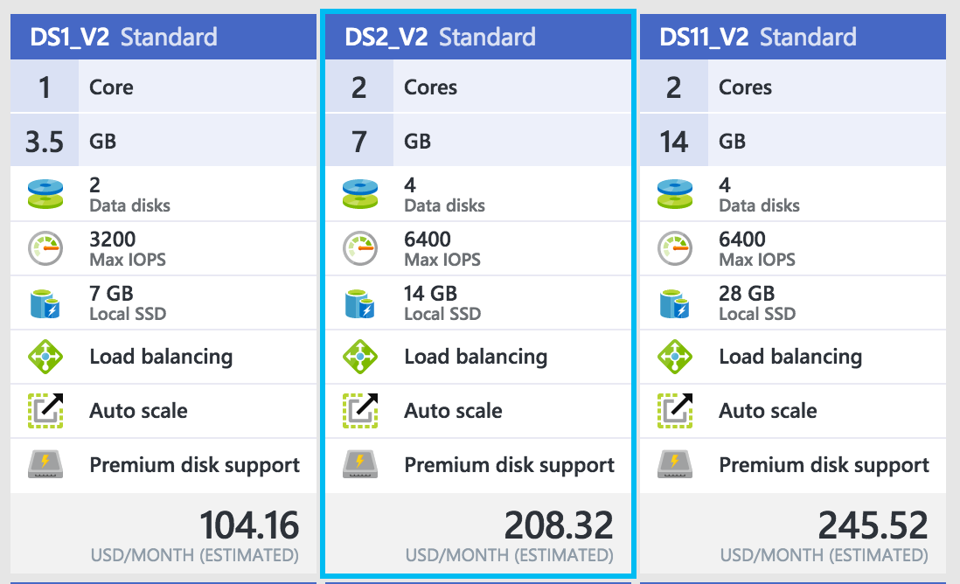

1. Accept the default values on the Settings blade by clicking **OK**.

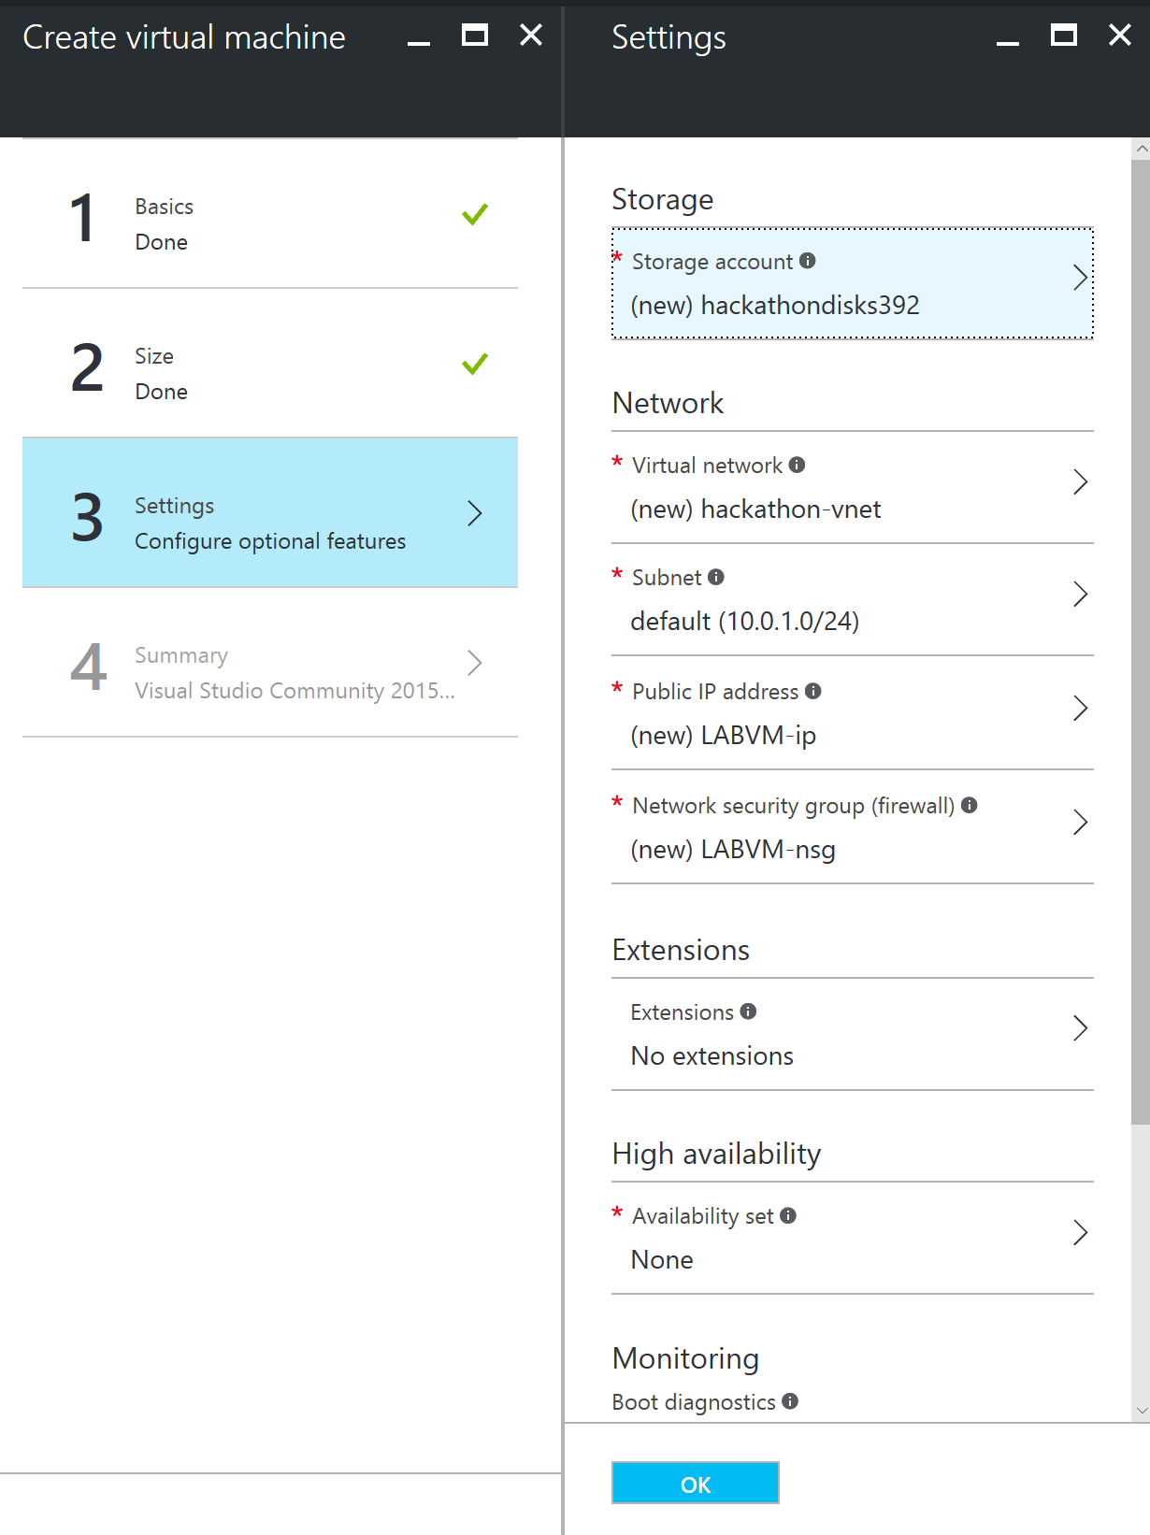

1. Click **OK** on the Summary blade to provision the virtual machine

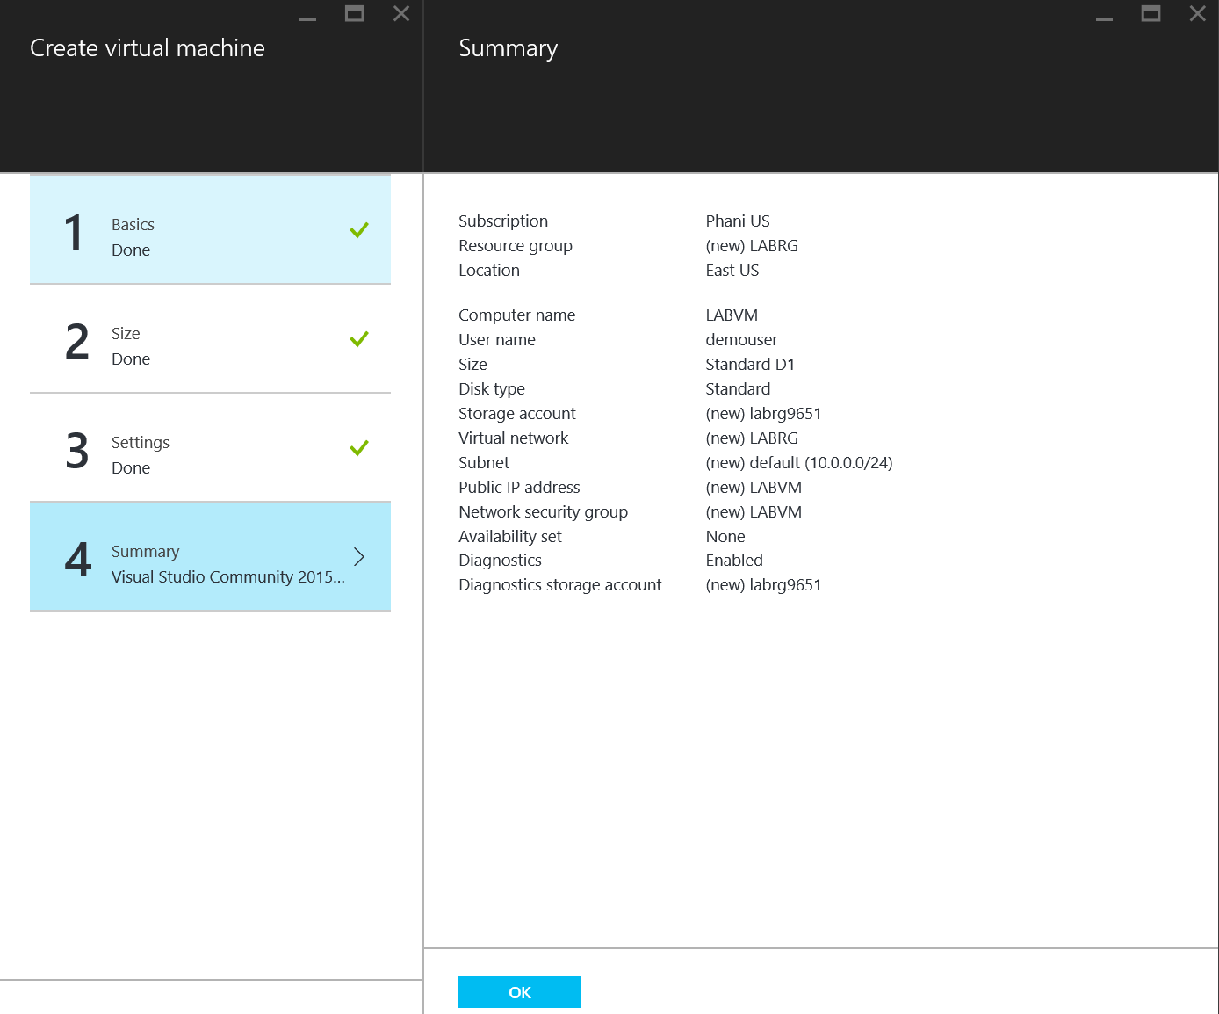

1. It may take 10+ minutes for the virtual machine to complete provisioning.

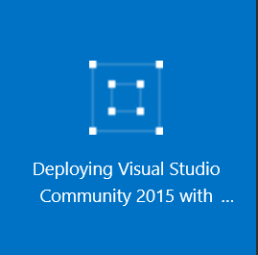

1. After the virtual machine is created, click the Connect button on the toolbar.

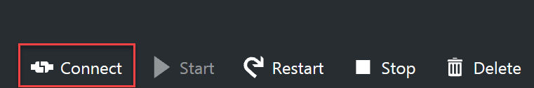

1. Depending on your remote desktop protocol client and browser configuration you will either be prompted to open an RDP file or you will need to download it and then open it separately to connect.
2. Login with the credentials specified during creation:
   1. User: demouser
   2. Password: demo@pass123

### Task 3: Install the required Azure components.

In this task, you will install the Azure SDK, the 1.0 version of the Azure PowerShell cmdlets, the Azure Cross Platform Command Line Interface (azurecli) and the Chrome browser.

1. After you connect to the VM, the Server Manager application should launch automatically.   
   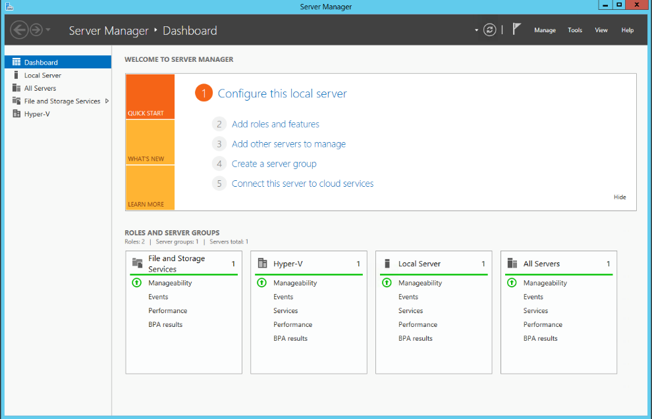
2. Click on the Local Server tab on the left-hand navigation bar.  
   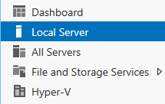
3. In the Properties pane, click the On link next to IE Enhanced Security Configuration.  
   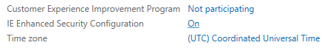
4. Change Administrators to the **Off** setting and click **OK**.  
   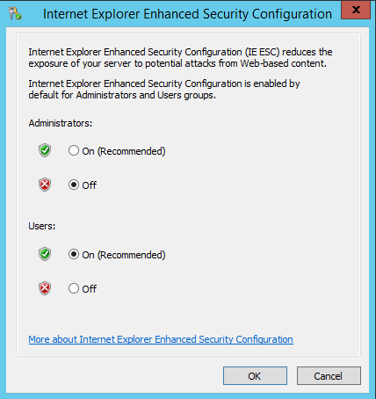
5. Launch a browser and navigate to: <https://azure.microsoft.com/en-us/downloads>
6. Click the **VS 2015** link under .NET, and when prompted click **Run** to install the latest Azure SDK. Complete the installation wizard before proceeding.

Note: This will also install the Azure PowerShell cmdlets 1.0.

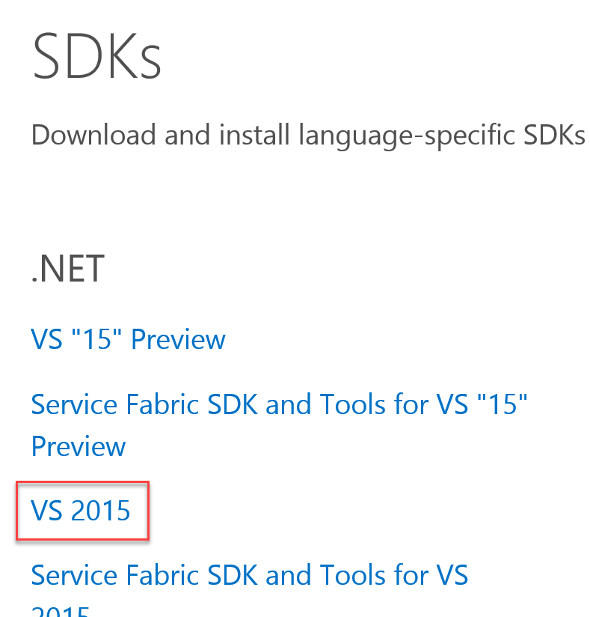

1. Next, install the Azure CLI tools by clicking the **Windows install** link on the same page and stepping through the installation wizard.

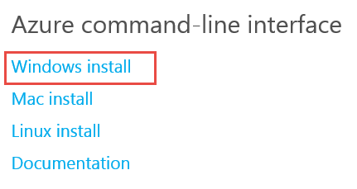

1. Download and install the **Chrome** browser from: https://www.google.com/chrome/browser/index.html
2. **Restart the lab machine when the installations are complete.**

## Exercise 1: Deploy SQL Server Instances

Duration: 60 minutes

Synopsis: In this exercise you will deploy a Virtual Machine in Azure that contains instances of both SQL Server 2008 and SQL Server 2016.

### Task 1: Spin up an Azure Virtual Machine

#### Tasks to complete

* Provision a Virtual Machine of SQL Server 2016 Developer and Windows Server 2012 R2.
  + Be sure to use an admin account student with a password of MSpassword11
* Add a network security rule allowing connectivity to SQL Server on port 1433.

#### Exit criteria

* You can Remote Desktop into the VM.

### Task 2: Install SQL Server 2008 R2

In these steps, you will install SQL Server 2008 R2.

#### Tasks to complete

* Install Server 2008 R2 Express with Advanced Services on the VM
  + <https://www.microsoft.com/en-us/download/details.aspx?id=30438>
  + Be sure that the SQL Server Database Engine runs under the student Windows account.
  + Enable Mixed Mode Authentication
    - Ensure the SA password is set to MSpassword11

#### Exit criteria

* You have successfully installed both versions of SQL Server on the same VM.

### Task 3: Install the AdventureWorks Sample Database

In this task you will install the AdventureWorks database as the source database to migrate.

#### Tasks to complete

* Download the AdventureWorks 2008R2 DW Script from: <https://msftdbprodsamples.codeplex.com/releases/view/59211>
* Execute instawdwdb.sql against the instance of SQL Server 2008 in your VM.
* Rename the database WorldWideImporters.
* Set the services account for the SQL Server service (in the SQL Server 2016 instance) to use the student Windows account.
* Ensure that remote TCP/IP connections are allowed to the SQL Server 2016 instance.
* Enable the SA login with password MSpassword11
* Create a new, empty database called Northwind

#### Exit criteria

* You have successfully created the Northwind target database and can access this SQL Server using SQL Server credentials.

## Exercise 2: Perform an Assessment for a Move to Azure SQL DB

Duration: 45 minutes

Synopsis World Wide Importers would like an assessment to see if what potentials issues they would have to address in moving their database to Azure SQL DB.

### Task 1: Perform an assessment

#### Tasks to complete

* + Use the Data Migration Assistant to perform an assessment for migrating the WorldWideImporters database to Azure SQL Database.

#### Exit criteria

* You can review the assessment results.  
  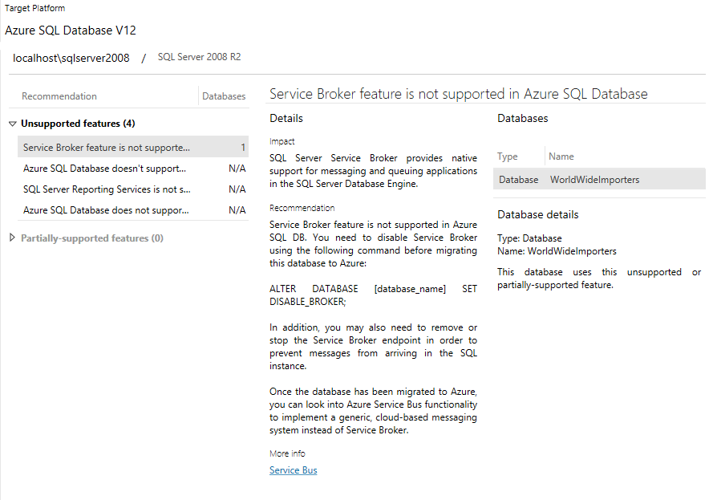

## Exercise 3: Upgrade the SQL Server 2008 database to SQL Server 2016

Duration: 30 minutes

World Wide Importers would like a POC that moves their database to SQL Server 2016 Enterprise. They would like to know about any incompatible features will block their eventual production move.

### Task 1: Migrate using Data Migration Assistant

#### Tasks to complete

* Migrate the WorldWideImporters database from SQL Server 2008 to SQL Server 2016 using the Data Migration Assistant (DMA).
  + Be sure to use Windows Authentication
  + Uncheck Encrypt connection and Trust server certificate
  + Provide a common shared folder within the VM for use as the “Shared location” used by DMA.

#### Exit criteria

* Your results indicate a successful upgrade.  
  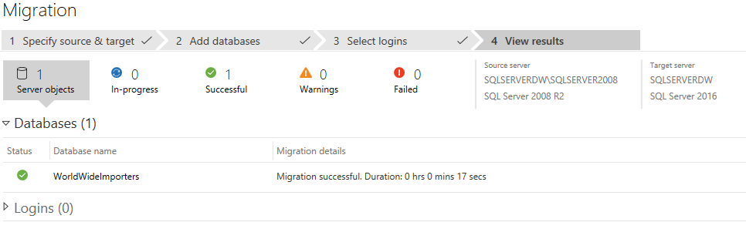

## Exercise 4: Post Upgrade Enhancement

Duration: 20 minutes

In this exercise, attendees will confirm that the POC was successful. To demonstrate value from the upgrade, the new features of SQL Server 2016 (Table Compression and Columnstore Index) will be enabled to immediately show benefit.

### Task 1: Table Compression

#### Tasks to complete

* Take note of the data space and index space used by the FactInternetSales table.
* Enable Table Compression (page type) on the FactInternetSales table.

#### Exit criteria

* You observe a change in the data space and index space.

### Task 2: Clustered Columnstore Index

#### Tasks to complete

* Create a new table called columnstore_FactResellerSales from the FactResellersSales table.
* Create a clustered columnstore index on the new table.
* Query the tables and compare the execution plan query costs, batch percentage.
* Query the tables with statistic io on and compare the logical and lob logical reads.

#### Exit criteria

* You observe a performance improvement.

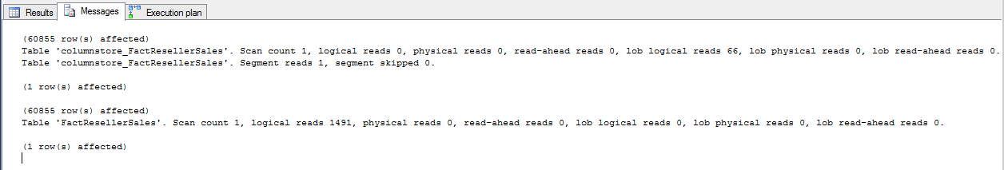

## Exercise 5: Setup Oracle 11g Express Edition

Duration: 60 minutes

In this exercise, you will install Oracle XE, load a sample database supporting an application and then migrate the database to use SQL Server 2016.

### Task 1: Install Oracle XE

#### Tasks to complete

* Install Oracle XE on your lab VM from: <http://www.oracle.com/technetwork/database/database-technologies/express-edition/downloads/index.html>
  + Be sure to set the SYS and SYSTEM password to oracledemo123

#### Exit criteria

* You have successfully installed Oracle.

### Task 2: Install Oracle Developer Tools for Visual Studio 2015

#### Tasks to complete

* Install Oracle Developer Tools for Visual Studio 2015 from: <http://www.oracle.com/technetwork/topics/dotnet/downloads/index.html>

#### Exit criteria

* You have successfully installed the tools on your Lab VM.

### Task 3: Install Oracle Client

#### Tasks to complete

* Install the Oracle Client from: <http://www.oracle.com/technetwork/topics/dotnet/utilsoft-086879.html>

#### Exit criteria

* You have successfully installed the Oracle Client on your Lab VM.

### Task 4: Install SQL Server Migration Assistant (SSMA) 7.0 for Oracle plus Extension Pack

#### Tasks to complete

* Install SSMA from: <https://www.microsoft.com/en-us/download/details.aspx?id=53120>
  + Install both SSMA and the Extension pack

#### Exit criteria

* You have successfully installed SSMA your Lab VM.

### Task 5: Create the Northwind database in Oracle 11g XE

#### Tasks to complete

* Download the starter files from: <http://bit.ly/oraclenorthwind>
* Using Server Explorer in Visual Studio, run the SQL scripts in order provided under the Oracle Scripts folder of the starter.

#### Exit criteria

* You have created the Northwind database with schema and data in Oracle.

### Task 6: Configure the Starter Application use Oracle

#### Tasks to complete

* Modify the web.config of the NorthwindMVC web app so the OracleConnectionString points to your Oracle instance of Northwind.

#### Exit criteria

* You have can run the application and see the Dashboard from Northwind Traders load.  
  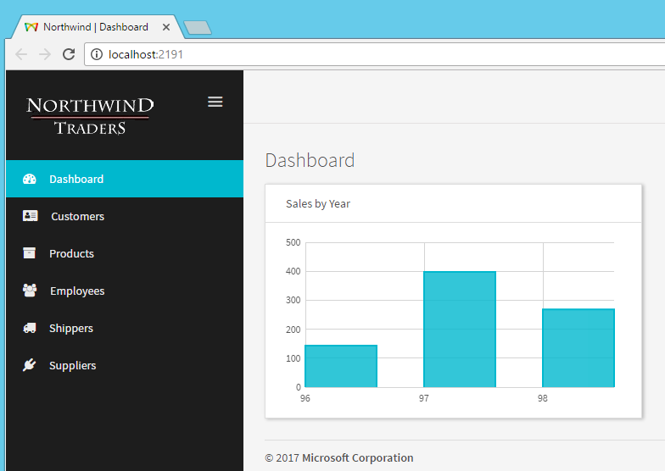

### Task 7: Migrate the Oracle database to SQL Server 2016 using SSMA

#### Tasks to complete

* Use SSMA to migrate the schema and data from the NW database on Oracle to the Northwind database in SQL Server 2016.

#### Exit criteria

* Your Northwind database in SQL Server has the schema objects and the tables have data.

## Exercise 6: Migrate the Application

Duration: 15 minutes

Synopsis: In this exercise, you will modify the NorthwindMVC application so it targets SQL Server instead of Oracle.

### Task 1: Create a new Entity Model against SQL Server

#### Tasks to complete

* Modify the web.config so that SqlServerConnectionString is correct for your environment.
* Delete the existing entity model present in the files under the Data folder in Solution explorer.
* Create a new Code First model against the SQL Server database.

#### Exit criteria

* You have successfully generated a new model.

### Task 2: Modify Application Code

#### Tasks to complete

* Change the DataContext to use your SqlServerConnectionString.
* Within HomeController.cs uncomment the SQL Server specific code and comment out the Oracle specific code.
* Modify SALESBYYEAR.cs so that YEAR is of type int.
* Modify SalesByYearViewModel.cs so that Year is of type int.
* Run the SALES_BY_YEAR_fix.sql

#### Exit criteria

* You can run the application and see the dashboard showing correctly, this time with data coming from SQL Server..  
  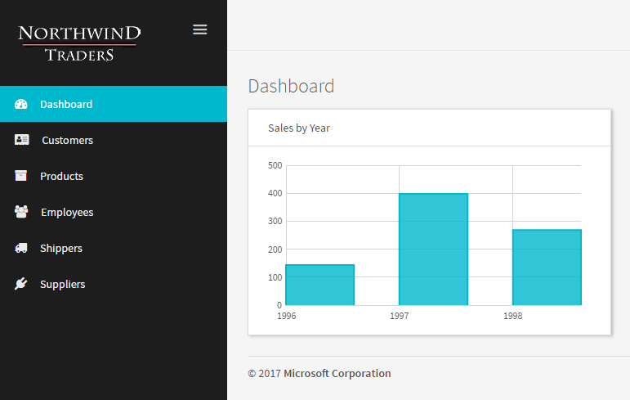

## Exercise 7: Cleanup

Duration: 5 minutes

Synopsis: In this exercise, attendees will de-provision any Azure resources that were created in support of the hackathon.

### Task 1: Clean up Azure Resources

Delete the Resource Group(s) containing the SQL Server 2016 VM you created and the Lab Virtual Machine (if you are finished doing hackathons).

# Database Upgrade & Migration hackathon answers

## Overview

World Wide Importers (WWI) has experienced significant growth in the last few years. In addition to predictable growth, they’ve had a substantial amount of growth in the data they store in their data warehouse. Their data warehouse is starting to show its age; slowing down during ETL and during critical queries. It was built on SQL Server 2008 R2 Standard Edition.

The WWI CIO has recently read about new performance enhancements of SQL Server 2016. She is excited about clustered columnstore indexes. In addition, she has chosen to upgrade to Enterprise Edition. She’s hoping that table compression will improve performance, backup time, lessen the load on the Storage Area Network (SAN).

World Wide Importers is concerned about upgrading their database to SQL Server 2016 or Azure SQL DB. The data warehouse has been successful for a long time. As it has grown, it has filled with data, stored procedures, views, and security. World Wide Importers wants assurance that if it moves its data store, it won’t run into any incompatibilities with the storage engine of SQL Server 2016.

She would like a POC of a data warehouse move and proof that the new technology will help ETL and query performance.

## Requirements

* Microsoft Azure subscription must be pay-as-you-go or MSDN.
  + Trial subscriptions will *not* work.
* Local machine or a virtual machine configured with:
  + Remote Desktop Client

## Exercise 0: Deploy your Development Virtual Machine

Duration: 60 minutes

Synopsis: Before attending the hackathon, you should follow these steps to prepare a development virtual machine environment for an efficient day.

### Task 1: Login

* 1. Launch a browser and navigate to https://portal.azure.com. Once prompted, login with your Microsoft Azure credentials. If prompted, choose whether your account is an organization account or just a Microsoft Account.
     1. **Note:** You may need to launch an "in-private" session in your browser if you have multiple Microsoft Accounts.

### Task 2: Create a new virtual machine

1. Click on the **+NEW** link.



1. Select **Compute** in the blade that comes up.
2. In the Compute blade select **See all**.



1. This will present the compute related gallery of resources from which you can select a particular image and create an instance.  
    

You can use the Search feature to filter the image that you are interested in. Enter **Visual Studio Community 2015** in the search box.



1. Then click on **Visual Studio Community 2015 Update 3 with Azure SDK 2.9 on Windows Server 2012 R2**.



1. In the blade that comes up, at the bottom, ensure the deployment model is set to **Resource Manager** and click **Create**.



1. Set the following configuration on the Basics tab.

* Name: LABVM
* VM disk type: HDD
* User name: demouser
* Password: demo@pass123
* Subscription: If you have multiple subscriptions choose the subscription to execute your labs in.
* Resource Group: hackathon
* Location: Choose the closest Azure region to you.



1. Click **OK** to move to the next step.
2. On the Choose a Size blade, click **View all**
3. Choose the instance size on the Size blade. We recommend at a machine with at least 7 GB of RAM to accommodate Visual Studio, so a **DS2 V2** standard is a good baseline option.



1. Accept the default values on the Settings blade by clicking **OK**.



1. Click **OK** on the Summary blade to provision the virtual machine



1. It may take 10+ minutes for the virtual machine to complete provisioning.



1. After the virtual machine is created, click the Connect button on the toolbar.



1. Depending on your remote desktop protocol client and browser configuration you will either be prompted to open an RDP file or you will need to download it and then open it separately to connect.
2. Login with the credentials specified during creation:
   1. User: demouser
   2. Password: demo@pass123

### Task 3: Install the required Azure components.

In this task, you will install the Azure SDK, the 1.0 version of the Azure PowerShell cmdlets, the Azure Cross Platform Command Line Interface (azurecli) and the Chrome browser.

1. After you connect to the VM, the Server Manager application should launch automatically.   
   
2. Click on the Local Server tab on the left-hand navigation bar.  
   
3. In the Properties pane, click the On link next to IE Enhanced Security Configuration.  
   
4. Change Administrators to the **Off** setting and click **OK**.  
   
5. Launch a browser and navigate to: <https://azure.microsoft.com/en-us/downloads>
6. Click the **VS 2015** link under .NET, and when prompted click **Run** to install the latest Azure SDK. Complete the installation wizard before proceeding.

Note: This will also install the Azure PowerShell cmdlets 1.0.



1. Next, install the Azure CLI tools by clicking the **Windows install** link on the same page and stepping through the installation wizard.



1. Download and install the **Chrome** browser from: https://www.google.com/chrome/browser/index.html
2. **Restart the lab machine when the installations are complete.**

## Exercise 1: Deploy SQL Server Instances

Duration: 60 minutes

Synopsis: In this exercise, you will deploy a Virtual Machine in Azure that contains instances of both SQL Server 2008 and SQL Server 2016.

### Task 1: Spin up an Azure Virtual Machine

1. Go to the Azure Portal (<https://portal.azure.com/>).
2. Select + New and in the “Search the marketplace” field type “sql server 2016 developer”.
3. Select the VM image of **SQL Server 2016 Developer and Windows Server 2012 R2**.
   1. We’re using an older version of Windows Server so that we can install SQL Server 2008 R2.



* 1. It’s the bottom one on this list.

1. After selecting the right gallery image, fill out the prompts similar to the following screenshot:

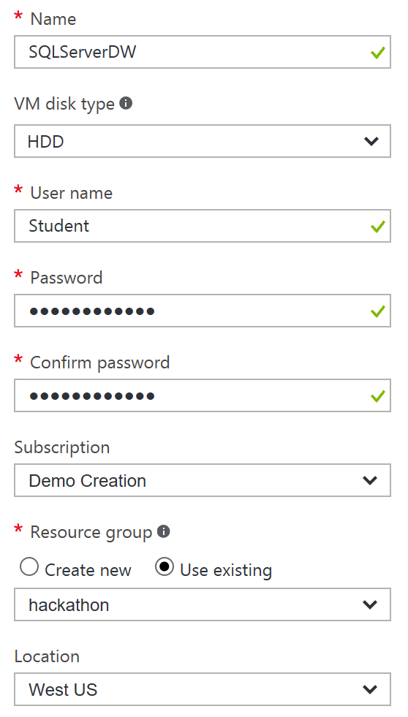

1. If you’re following along, change these items:
   1. Name: SQLServerDW
   2. VM disk type: HDD
   3. User name: Student
   4. Password: MSpassword11
   5. Create or select a resource group and choose a location that is close to you.
2. Choose a VM size. For future exercises, it doesn’t need to be very large. You can choose a DS1_V2.



1. Click OK to the rest of the prompts and create the VM.
2. When the VM finishes provisioning, you will need to create a network security rule that allows remote systems to connect with SQL Server. On the blade for the virtual machine, select Network Interfaces, select the only entry in the list, select Network security group and select the only network security group listed.
3. Select Inbound security rules.  
   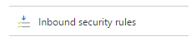
4. Select + Add.
5. Add a new rule configured as follows:
   1. Name: SqlServer
   2. Priority: 1010
   3. Source: Any
   4. Service: Select MS SQL
   5. Protocol: Should autofill to TCP
   6. Port range: Should autofill to 1433
   7. Action: Allow

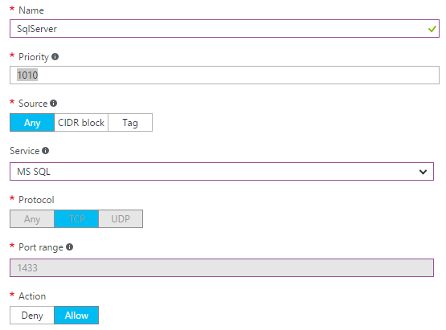

1. Select OK to create the security rule.
2. Close the open blades until you are back at the blade for your Virtual Machine.
3. Click Connect in the Azure Portal to download a file to use with RDP.
4. Logon using RDP. Use the Student username and password you specified earlier.

### Task 2: Install SQL Server 2008 R2

Within your RDP connection to the virtual machine perform the following steps.

1. Within Server Manager, select Local Server and select IE Enhanced Security Configuration.
2. In the dialog set this to Off for Administrators and select OK.  
   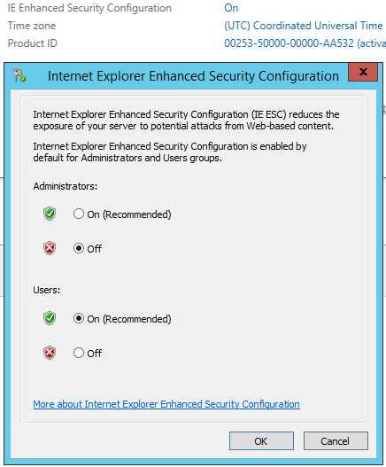
3. Download SQL Server 2008 R2 Express with Advanced Services
   1. Using Internet Explorer, navigate to: <https://www.microsoft.com/en-us/download/details.aspx?id=30438>
   2. Select Download
   3. Select SQLEXPERADV_x64_ENU.exe
4. Install SQL Server 2008 R2 Express on to the VM.
   1. Open SQLEXPERADV_x64_ENU.exe that you downloaded earlier.
   2. On the SQL Server Installation Center, select New installation or add features to an existing installation.

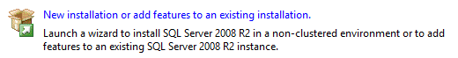

* 1. You can accept the default values for most selections, except the following:



* 1. Specify an instance name, SQLServer2008.
  2. When you can specify a service account, use the student account you created when you created the VM.

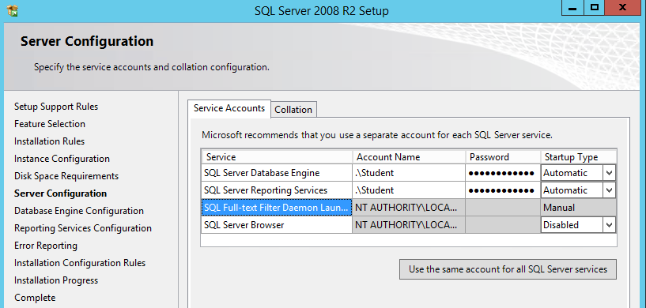

* 1. Put the server in Mixed Mode. Use the SA password: MSpassword11
  2. Click “Add Current User” to specify SQL Server Administrators.



* 1. Click Next to accept the rest of the install values.

### Task 3: Install the AdventureWorks Sample Database

In this task, you will install the AdventureWorks database as the source database to migrate.

1. Download a sample database from the following link:
   1. <https://msftdbprodsamples.codeplex.com/releases/view/59211>
   2. Download the **AdventureWorks 2008R2 DW Script**.



* 1. It’s the last link on this list.
  2. Unzip the file to a folder you create called C:\AdventureWorksSample.
  3. In the folder, there is a file called **instawdwdb.sql**. Open it with SQL Server Management Studio 2016 (SSMS).
  4. When SQL Server Management Studio loads, connect to your SQLServer2008 instance.
  5. Uncomment and edit the SETVAR lines (line 36 and 37) so they point to C:\AdventureWorksSample\ (the DataPath variable should point to C:\AdventureWorksSample\AdventureWorks 2008R2 Data Warehouse\). Remember to put a trailing backslash on the path.

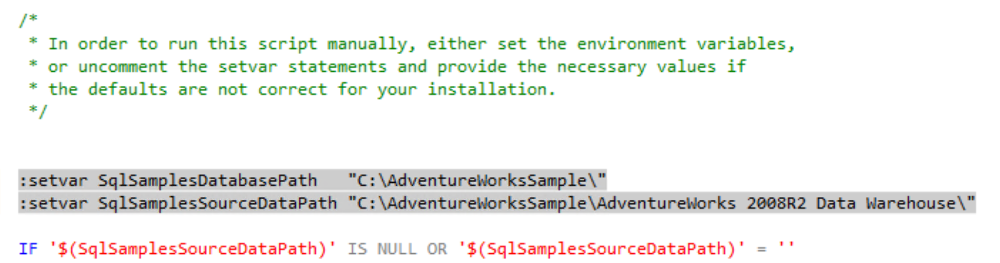

* 1. Put SSMS into SQLCMD mode. You can find that selection in the Query dropdown menu.

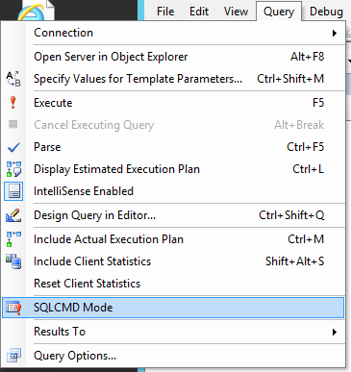

* 1. Run the query to create the AdventureWorks2008R2DW database.
  2. Connect Object Explorer to your SQLServer2008 instance by using the Connect menu, selecting Database engine and the providing your authentication credentials (you can leave this at Windows Authentication).
  3. Expand databases, right click AdventureWorksDW2008R2 and select Rename.
  4. Rename the database to WorldWideImporters.



* 1. From the Start Menu, search for SQL Server 2016 Configuration Manager and change the service account that SQL Server uses.
     1. From the tree, select SQL Server Services.
     2. In the list of services, double click SQL Server (MSSQLSERVER) to open its configuration.
     3. Change the Log On user to use the Student Account. The screen should look like the following:



1. Click OK to apply the changes.
2. Click Yes to restart the service.
3. While still in SQL Server 2016 Configuration Manager, expand SQL Server Network Configuration, select Protocols for MSSQLSERVER and double click on TCP/IP to open the properties.
4. On the Protocol tab, set Enabled to Yes and select OK.

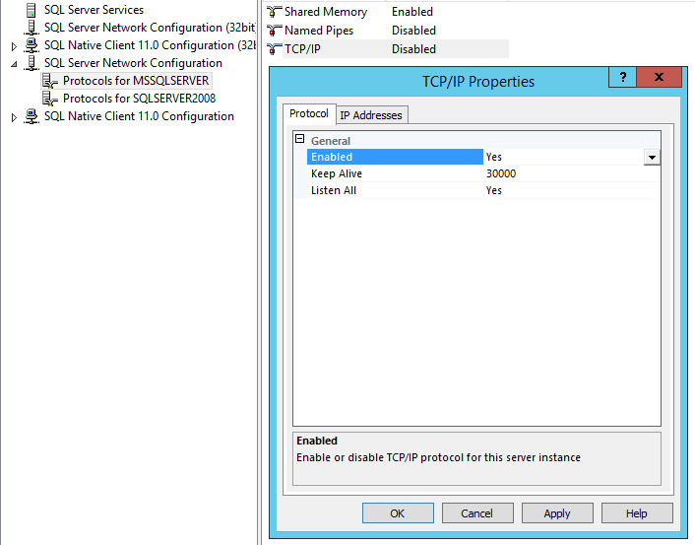

1. When prompted to that you will need to restart the services, select OK. You will restart the services later.
2. Launch Microsoft SQL Server Management Studio.
3. Set Authentication to Windows Authentication and select Connect.  
   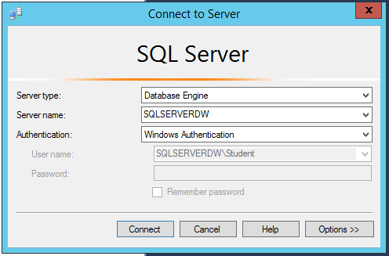
4. In Object Explorer, right click your server and select properties.

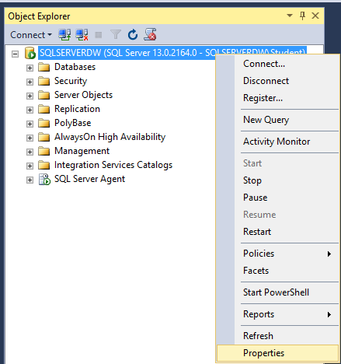

1. Select the Security page and change the Server authentication to SQL Server and Windows Authentication mode.  
   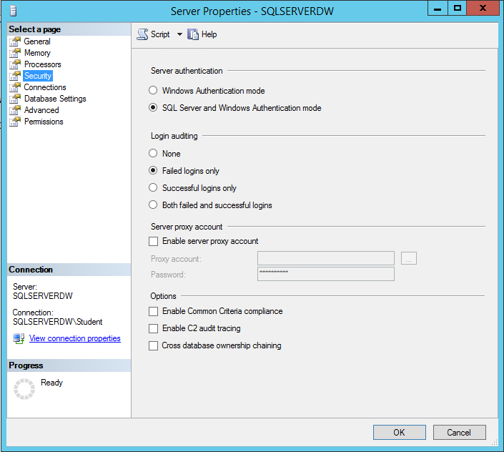
2. Select OK.
3. In Object Explorer, expand Security, Logins and right-click SA and select Properties.  
   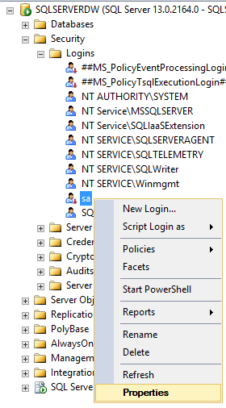
4. In the Login Properties panel, in the Password and Confirm password fields enter MSpassword11.
5. Select OK.
6. Open the Properties dialog on sa once more, and navigate to the Status page.

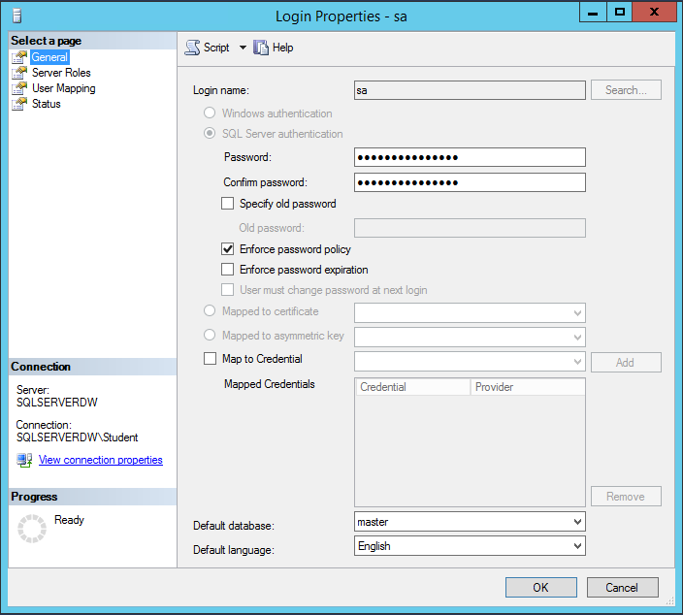

1. Change the Login to Enabled.
2. Select OK.  
   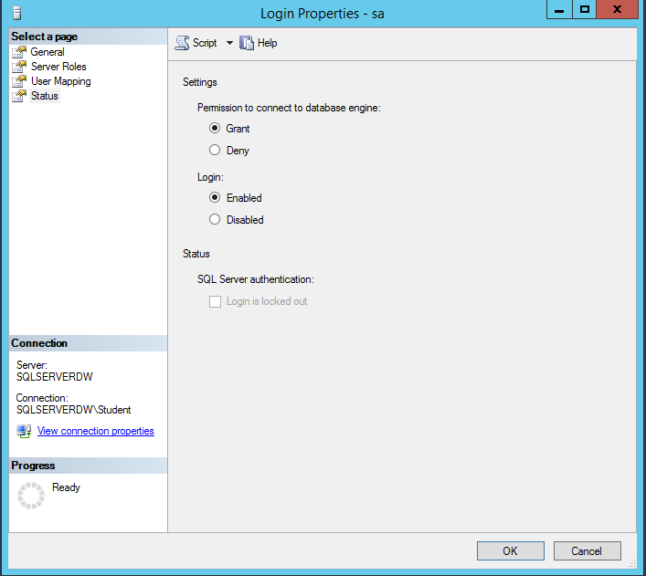
3. In Object Explorer, right click the Databases folder and select New Database…

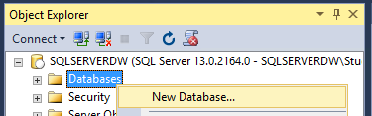

1. Provide the Database name Northwind and select OK.  
   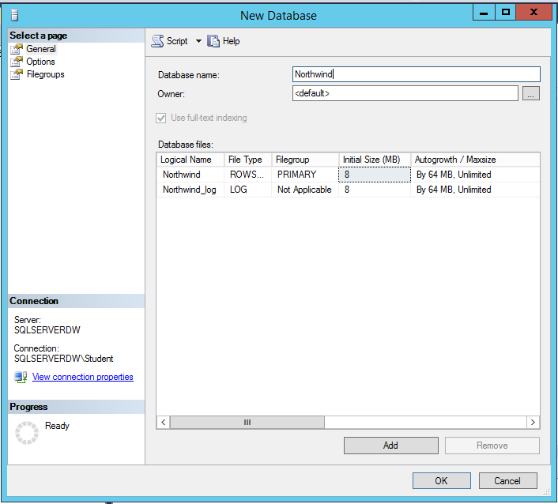
2. Return to SQL Server Configuration Manager.
3. In SQL Server Configuration Manager, select SQL Server Services and right click SQL Server (MSSQLSERVER) and select Restart.
4. Select SQL Server Agent (MSSQLSERVER) and select Start.  
   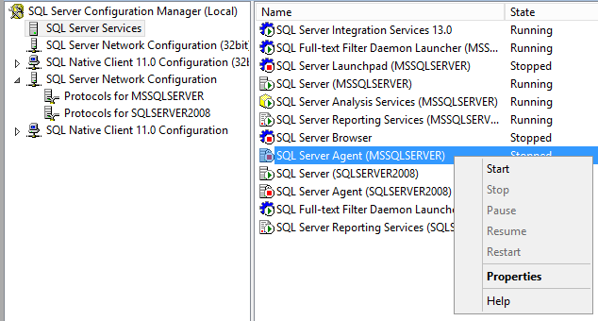

## Exercise 2: Perform an Assessment for a Move to Azure SQL DB

Duration: 45 minutes

Synopsis World Wide Importers would like an assessment to see what potential issues they would have to address in moving their database to Azure SQL DB.

### Task 1: Perform an assessment

1. Download the Data Migration Wizard 3.0 from <https://www.microsoft.com/en-us/download/details.aspx?id=53595>
2. Install the tool. Accept the defaults.
3. Start the Microsoft Data Migration Assistant.
4. Select + New
5. Fill out the project settings like the following screenshot:



* 1. Choose the Assessment radio button
  2. Call the project name “Assessment”
  3. Leave the source and target server types the default selections

1. Click Create
2. Leave the target version at version 12.
3. Make sure check database compatibility and check feature parity are selected.  
   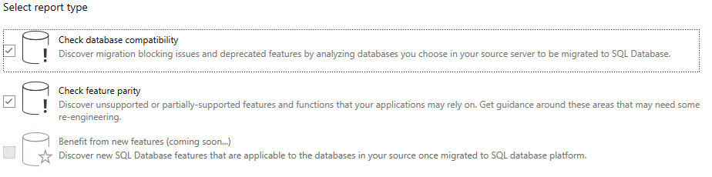
4. Click Next
5. On the next screen, the fillable fields are on the right.
6. For the target server, type localhost\sqlserver2008 as the source server.
7. Leave the Authentication Type as Windows Authentication.
8. Make sure Encrypt Connection and Trust server certificate are both cleared (deselected.)
9. It should look like this screenshot:



1. Select Connect.
2. Choose the WorldWideImporters database



1. Select Add
2. Select Start Assessment
3. Review Assessment results  
   
4. You now have the list of issues WWI will need to consider in upgrading their database to SQL Database. Notice that assessment includes recommendations on the potential resolution.

## Exercise 3: Upgrade the SQL Server 2008 database to SQL Server 2016

Duration: 30 minutes

World Wide Importers would like a POC that moves their database to SQL Server 2016 Enterprise. They would like to know about any incompatible features will block their eventual production move.

### Task 1: Migrate using Data Migration Assistant

1. Open Data Migration Assistant 3.0
2. Click the + NEW.
3. Under Project type, select Migration
4. Name the project Migration
5. The Target server type should automatically change to SQL Server (currently DMA only supports migrations to SQL Server- it does not yet support migrations to SQL Database).
6. Your screen should look like this:



1. Select Create
2. Change the Source server name to localhost\sqlserver2008
3. Change the Target server name to localhost
4. Make sure the Encrypt connect and Trust server certificate checkboxes are cleared on both sides of the migration.
5. You screen should look like this:



1. Select Next.
2. Make sure ONLY the WorldWideImporters database is selected on the far left.
3. Go to File Explorer
   1. Create a folder in the root of C: called backupshare.
   2. Share the folder by right-clicking on it, selecting Properties and then navigating to the Sharing tab. Select Share…  
      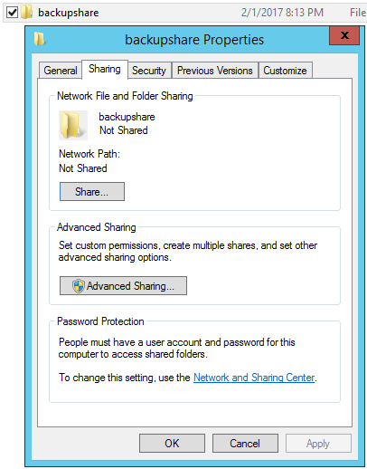
   3. The defaults should allow the student account to read/write.
      1. The Student account is the one you are logged in as and the one both SQL Server source and target are using as their service accounts.
   4. Select Share.
   5. Select Done and close.
4. Return to Data Migration Assistant
5. Under the Shared location header, change the textbox to [\\localhost\backupshare](https://microsoft.sharepoint.com/backupshare).



1. Leave the rest of the fields as they are and click Next.
2. Leave the defaults and click Start Migration.



1. Review the results. You may also wish to select Export report, to save the report as CSV for review.  
   

## Exercise 4: Post Upgrade Enhancement

Duration: 20 minutes

In this exercise, attendees will confirm that the POC was successful. To demonstrate value from the upgrade, the new features of SQL Server 2016 (Table Compression and Columnstore Index) will be enabled to immediately show benefit.

### Task 1: Table Compression

1. Open **Microsoft SQL Server Management Studio 2016**. There are two versions of SSMS installed, so remember to choose the correct one (the 2016 version has Microsoft in the shortcut name).
2. In Object Explorer, connect to the default instance of localhost.
3. Expand Databases, WorldWideImporters, Tables and then right-click on the FactInternetSales table and select Properties.



1. Click the Storage tab of the Properties window.
2. Record the data space and index space being used.



1. Click Cancel.
2. Right-click the table again, but this time click the Storage context menu. Select Manage Compression.



1. Under Manage Compression Wizard, select Next.
2. On the Select Compression Type screen, select Row in the Compression type column and then select Calculate to see a simulated answer of how beneficial Row compression will be.
3. Then change the Compression type to Page and select Calculate.
4. Leave it on Page and select Next.



1. Select the Run Immediately radio button and select Finish.



1. Select Next.
2. Select Finish.
3. When the script finishes, select Close.
4. Return to the Properties window, Storage tab and record the data space and index space again. Notice the improvement with compression.
5. Compression decreases the load on the Disk I/O subsystem while increasing the load on the CPU. Since most data warehouse workloads are heavily disk bound and often have low CPU usage, compression can be a great way to improve performance.

### Task 2: Clustered Columnstore Index

Duration: 20 minutes

1. Create a new table based on the existing FactResllerSales table. Ensure you’re connected to the SQL Server 2016 default instance. You can use the following script.

use WorldWideImporters

select *

into columnstore_FactResellerSales

from FactResellerSales

go

1. In Object Explorer, on the new table, right-click on Properties. If you don’t see the new table, select the refresh button at the top of Object Explorer.
2. Click the Storage tab.
3. Record the data space and index space.
4. Create a columnstore index on the new table. You may use the following script:

USE [WorldWideImporters]

GO

CREATE CLUSTERED COLUMNSTORE INDEX [cci_FactResllerSales]

ON [dbo].[columnstore_FactResellerSales]

1. Return to the Storage tab of the Properties window and record the data and index space again.
2. Run the following query with the Include Actual Execution Plan by clicking on this button on the toolbar:



1. Run the following queries:

select productkey

, salesamount

from columnstore_factresellersales

select productkey

, salesamount

from factresellersales

1. In the results pane, select Execution Plan. Check the (relative to the batch) percentage value of the two queries and compare the two.  
   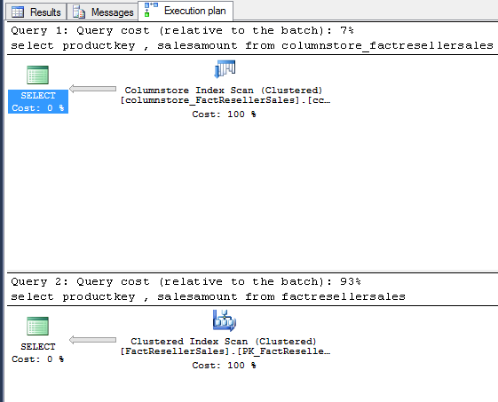
2. Run the query again, but this time, set statistics io on in the query as follows:

set statistics io on

go

select productkey

, salesamount

from columnstore_factresellersales

select productkey

, salesamount

from factresellersales

1. Statistics IO reports the amount of logical pages that are read in order to return the query results. Compare two numbers in the messages tab, logical reads and lob logical reads. You should see a significant drop in total number of pages read on the columnstore table.



## Exercise 5: Setup Oracle 11g Express Edition

Duration: 60 minutes

In this exercise, you will install Oracle XE, load a sample database supporting an application and then migrate the database to use SQL Server 2016.

### Task 1: Install Oracle XE

1. Remote desktop into your development environment VM (the one with Visual Studio pre-installed).
2. Within the remote desktop session, download Oracle Database 11g Express Edition Release 2 (32 bit) from: <http://www.oracle.com/technetwork/database/database-technologies/express-edition/downloads/index.html>  
   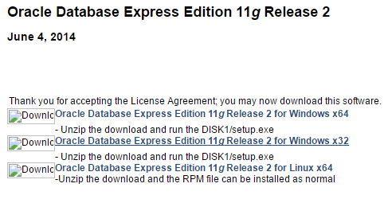
3. If you don’t already have a free Oracle Account, you will need to create one to complete the download. Otherwise, sign-in with your Oracle Account.

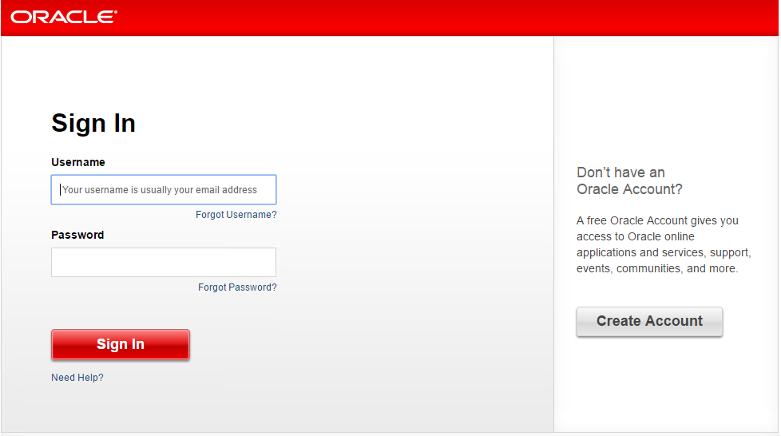

1. Unzip the file and navigate to the DISK1 folder and right click setup.exe and select Run as administrator.
2. Click through the setup wizard accepting the defaults until you get to the Specify Database Passwords.
   1. For the Enter Password and Confirm Password set it to: oracledemo123  
      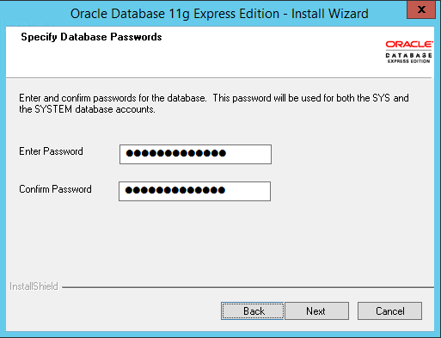
3. Select next.
4. On the summary dialog, take note of your ports.  
   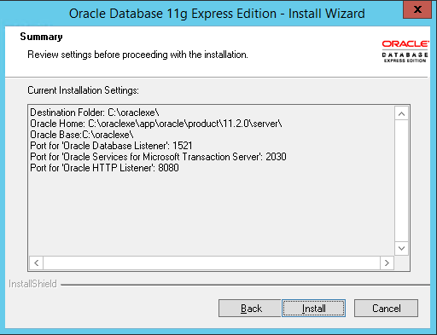
5. Select Install to begin the installation.
6. Select Finish on the final dialog to complete the install.

### Task 2: Install Oracle Developer Tools for Visual Studio 2015

1. Remote desktop into your development environment VM (the one with Visual Studio pre-installed).
2. Within the remote desktop session, download the Oracle Developer Tools for Visual Studio 2015 from: <http://www.oracle.com/technetwork/topics/dotnet/downloads/index.html>  
   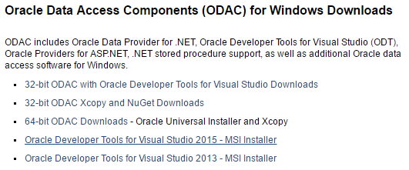
3. Accept the License Agreement and select the file name (ODTforVS2015_121025.exe) to begin the download.  
   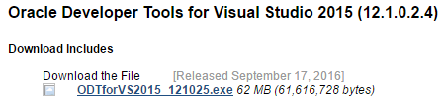
4. Double click the downloaded file to begin the setup.
5. At the Open File Security Warning select Run.
6. Complete the wizard leaving all values at the default.

### Task 3: Install Oracle Client

1. Within the remote desktop session, download the Oracle Client from: <http://www.oracle.com/technetwork/topics/dotnet/utilsoft-086879.html>
2. Accept the License Agreement and select the file name (ODTwithODAC121024.zip) to begin the download.
3. Unzip the file.
4. Double click on setup.exe to launch the installation.
5. Leave all settings at their defaults and complete the installation.

### Task 4: Install SQL Server Migration Assistant (SSMA) 7.0 for Oracle plus Extension Pack

1. Remote desktop into your development environment VM (the one with Visual Studio pre-installed).
2. Within the remote desktop session, download SSMA from: <https://www.microsoft.com/en-us/download/details.aspx?id=53120>
3. Select the Download button.  
   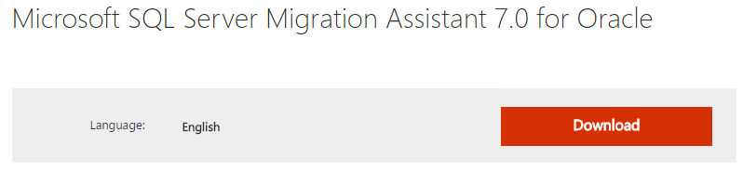
4. Select both files and then select Next to begin the downloads.  
   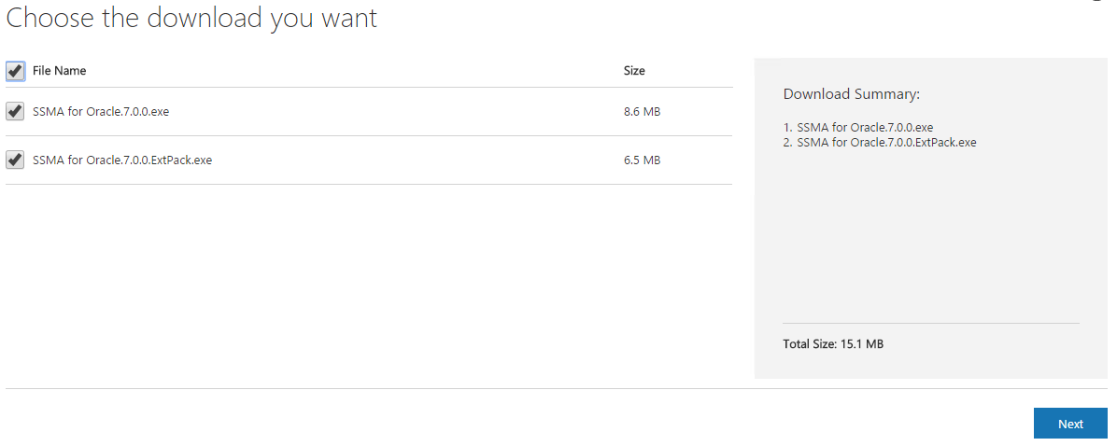
5. When the downloads complete, open SSMA for Oracle.7.0.0.exe to start the installation of SSMA.
6. At the Open File Security Warning select Run.
7. Step through the wizard leaving all settings at their defaults. Do not worry if you get a warning about being unable to find the Oracle Client.

### Task 5: Create the Northwind database in Oracle 11g XE

1. Download the start files from: <http://bit.ly/oraclenorthwind>
2. Unzip the folder to C:\hackathon
3. Launch Visual Studio 2015
4. Within Visual Studio, select File, Open Project/Solution and navigate to NorthwindMVC.sln in c:\hackathon.
5. From the View menu, select Server Explorer.
6. In Server Explorer, right click Data Connections and select Add connection…  
   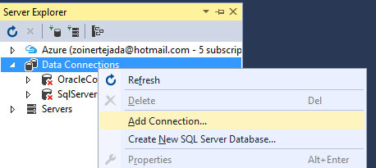
7. On the Add Connection dialog, provide your User name (SYSTEM) and password (oracledemo123).
8. Under Connect as SYSDBA change the Connection Type to EZ Connect and provide the following values:
   1. Database host name: localhost
   2. Port number: 1521
   3. Database service name: XE
   4. Connection name: Northwind  
      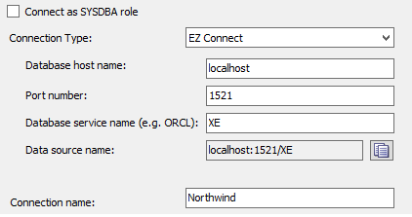
9. Select Test Connection to verify your settings.

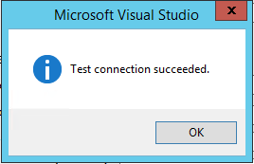

1. Select OK.
2. In Server Explorer, right click the Northwind node and select Query Window  
   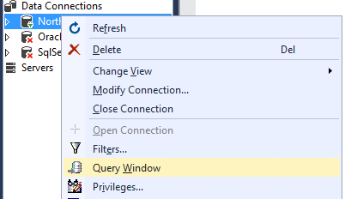
3. In Visual Studio, select File, Open, File and navigate to c:\hackathon\Oracle Scripts\1.northwind.oracle.schema.sql. and open it. It should open within your Oracle Query Window.
4. Select all of the file contents (use Control + A).
5. Press the green play icon at the top to run your script against Oracle.
6. In Server Explorer, right click Northwind and select Modify Connection…   
   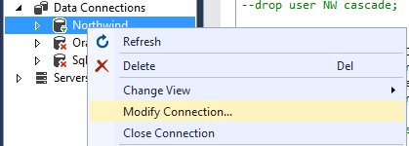
7. In the Modify Connection dialog, change the username and password as follows:
   1. User name: NW
   2. Password: oracledemo123
8. Select Test Connection to verify your new credentials work.
9. Select OK.
10. In Visual Studio, select File, Open, File and navigate to c:\hackathon\Oracle Scripts\2.northwind.oracle.tables.views.sql. and open it.
11. Select all of the file contents (use Control + A).
12. Press the green play icon at the top to run your script against Oracle.
13. In Visual Studio, select File, Open, File and navigate to c:\hackathon\Oracle Scripts\3.northwind.oracle.packages.sql. and open it. It should open in your Oracle Query Window.
14. Select all of the file contents (use Control + A).
15. Press the green play icon at the top to run your script against Oracle.
16. Repeat the previous steps 22-24 with:
    1. 4.northwind.oracle.sps.sql
    2. 5.northwind.oracle.seed.sql
    3. 6.northwind.oracle.constraints.sql

### Task 6: Configure the Starter Application to use Oracle

1. Within Visual Studio, Build the NorthwindMVC solution.
2. From Solution Explorer, open web.config and verify the connection string with key OracleConnectionString matches the values you have used in this hackathon:

DATA SOURCE=localhost:1521/XE;PASSWORD=oracledemo123;USER ID=NW

1. Save the web.config
2. Run the solution.
3. You should see the Dashboard from Northwind Traders load.  
   

### Task 7: Migrate the Oracle database to SQL Server 2016 using SSMA

1. Launch Microsoft SQL Server Migration Assistant for Oracle (32 Bit) from the Start Menu.
2. Select File, New Project.

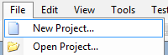

1. Set the Migrate To dropdown to SQL Server 2016.  
   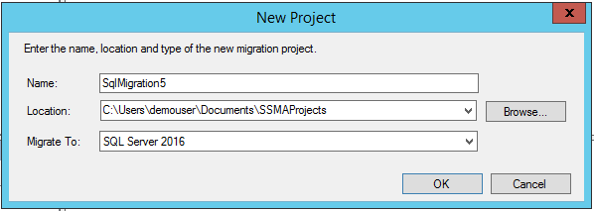
2. Select OK
3. Select the Connect to Oracle button in the command bar at the top of SSMA.  
   
4. In the Connect to Oracle dialog, set the mode to Standard mode and then enter your connection information as follows:
   1. Server name: localhost
   2. Server port: 1521
   3. Oracle SID: XE
   4. User name: NW
   5. Password: oracledemo123  
      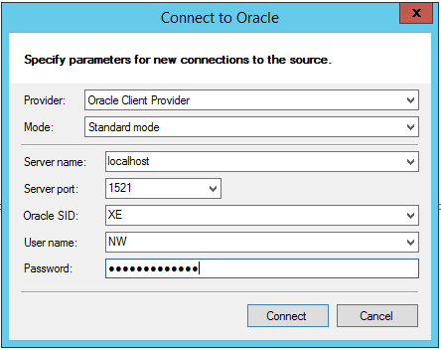
5. Select Connect.
6. Under Oracle Metadata Explorer, expand the localhost node, Schemas and confirm you can see the NW schema which will be the source for the migration.   
   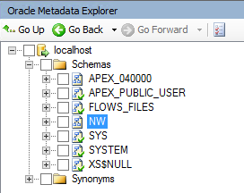
7. Next, add your connection to your SQL Server 2016 instance by selecting Connect to SQL Server from the command bar.  
   
8. In the Connect to SQL Server dialog, provide the following and select Connect:
   1. Server name: IP Address of your VM with SQL Server (you can get this from the Azure Portal, looking at the Essentials area of your VM’s blade).
   2. Server port: leave as [default]
   3. Database: Northwind
   4. Authentication: Change to SQL Server Authentication
   5. User name: sa
   6. Password: MSpassword11
9. In SQL Server Metadata Explorer, you should expand Databases folder and you should see Northwind listed.  
   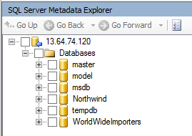
10. In the Oracle Metadata Explorer, check the box for NW and make sure it is selected in the tree.
11. In SQL Server Metadata Explorer check the box for Northwind.
12. In the command bar at the top, select Convert Schema.  
    
13. In about a minute the conversion should have completed.
14. In SQL Server Metadata Explorer, observe that new schema objects have been added. For example, underneath Northwind, NW, Schemas, Tables you should see the tables from the Oracle database.

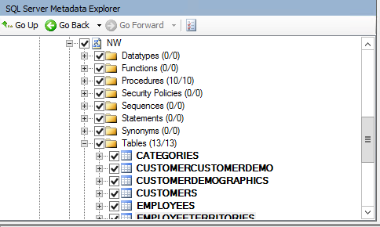

1. At the bottom, left of the screen select the Error List.  
   
2. Select Warnings to hide the warnings and leave only Errors displayed.  
   
3. Double click on the error listed to view the Table on the both sides (Oracle and SQL Server) that is causing the issue—the EMPLOYEETERRITORIES table.
4. Look at the table definition for the Table on the Oracle Side.
5. Change the Data Type from float(53) to int by going to the Type Mapping tab, selecting the row with source type of number and selecting Edit.

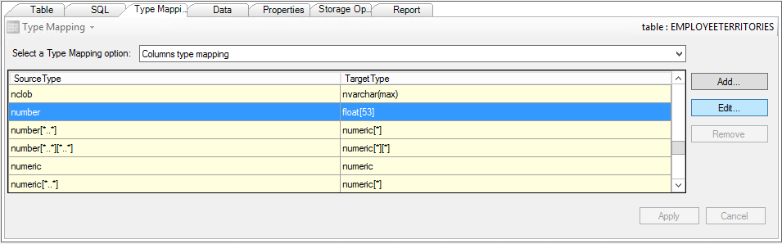

1. Set the Target type to int and select OK.  
   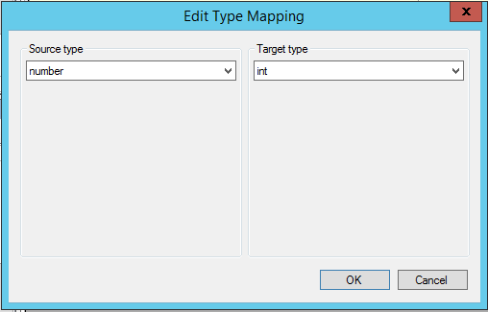
2. Select Apply (on the Type Mapping tab).

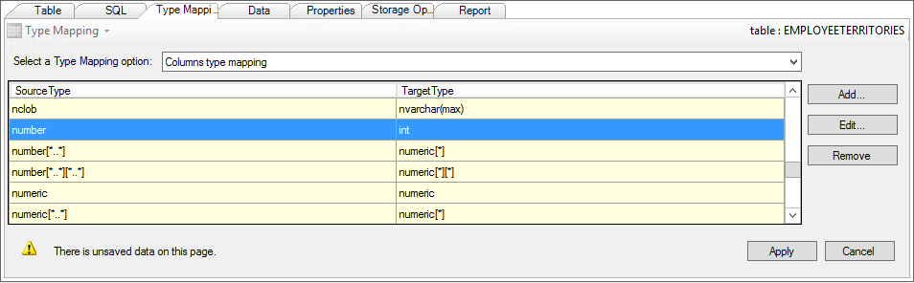

1. In the Oracle Metadata Explore, right click EMPLOYEETERRITORIES and select Convert Schema.  
   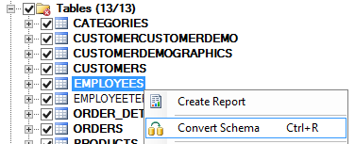
2. When prompted that the target exists, select Overwrite.  
   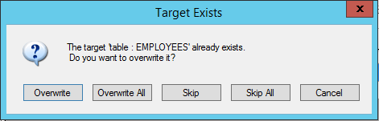
3. Save the project.
4. To apply the resultant schema to Northwind database in SQL Server use the SQL Server Metadata Explorer to view the Northwind database. Right click Northwind and select Synchronize with Database.

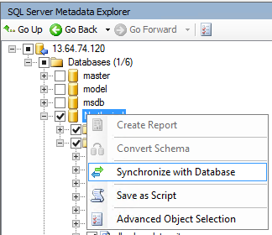

1. In the Synchronize with the Database dialog, select OK.
2. This will actually create all of the schema objects in the SQL Server Northwind database.
3. Now you need to migrate the data. In Oracle Metadata Explore, select NW and from the command bar, select Migrate Data.  
   
4. You will be prompted to re-enter your Oracle credentials for use by the connection used for migrating the data, recall they are:
   1. Server name: localhost
   2. Server port: 1521
   3. Oracle SID: XE
   4. User name: NW
   5. Password: oracledemo123
5. Select Connect.
6. You will be prompted to re-enter your SQL Server credentials for use by the connection used for migrating the data, recall they are:
   1. Server name: IP Address of your VM with SQL Server (you can get this from the Azure Portal, looking at the Essentials area of your VM’s blade).
   2. Server port: leave as [default]
   3. Authentication: Change to SQL Server Authentication
   4. User name: sa
   5. Password: MSpassword11
7. Select Connect.
8. After the migration completes, you will be presented with a Data Migration Report showing that the data from all tables was successfully migrated.  
   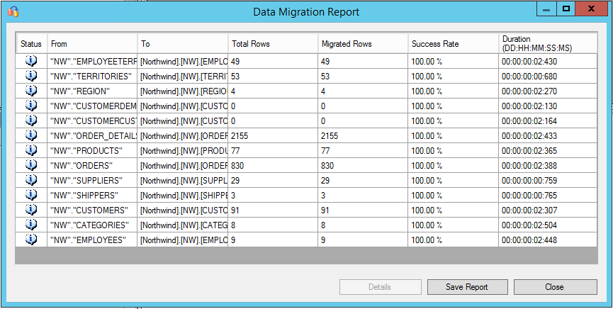

## Exercise 6: Migrate the Application

Duration: 15 minutes

Synopsis: In this exercise, you will modify the NorthwindMVC application so it targets SQL Server instead of Oracle.

### Task 1: Create a new Entity Model against SQL Server

1. Return to Visual Studio.
2. Open web.config in the solution root and modify the connection string named *SqlServerConnectionString* to match your remote SQL Server credentials.
3. Build the solution.
4. In the **Data** folder, select all the files within that folder, right-click, and choose **Delete**.  
   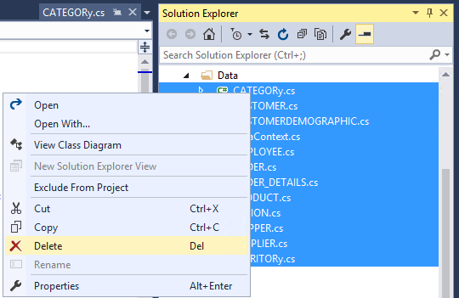
5. Select OK to confirmation prompt.
6. Right-click on the Data folder and choose **Add** > **New Item…**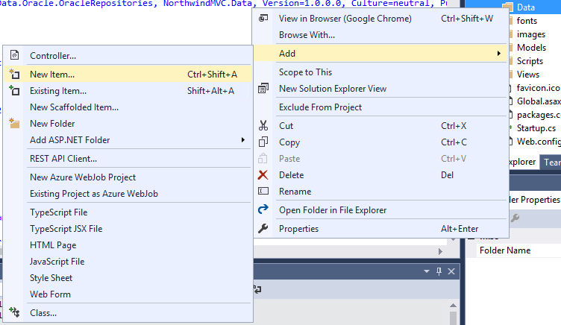
7. Under Visual C#, select Data and in the main panel select ADO.NET Entity Data Model.
8. For the name, enter **DataContext** and select Add.  
   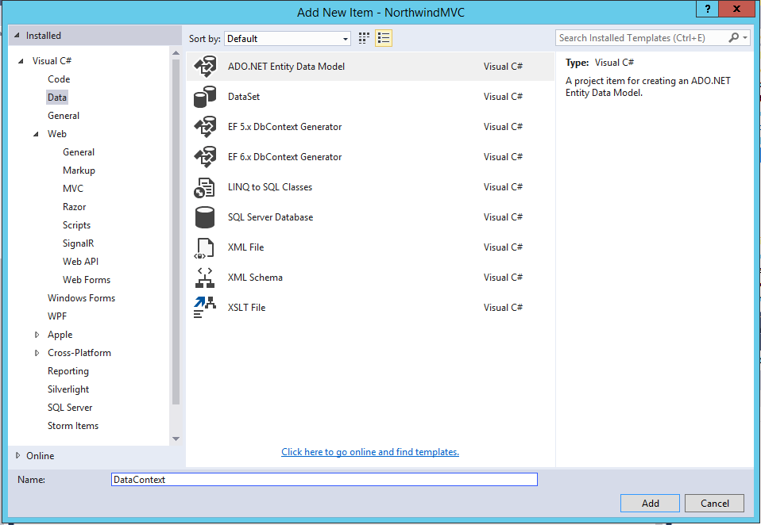
9. In the **Choose Model Content** dialog, choose **Code First from database** and click **Next >**.  
   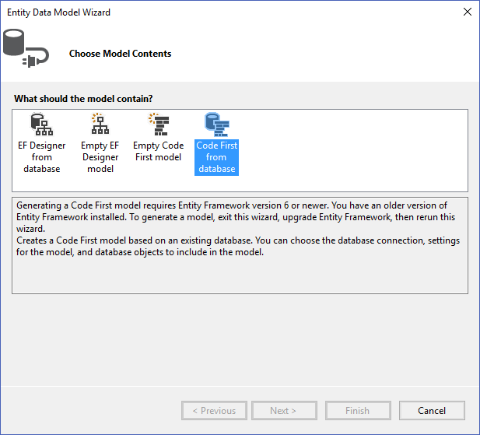
10. In the Choose your Data Connection dialog, choose **SQLServerConnectionString** (Settings) from the dropdown, select **Yes, include the sensitive data in the connection string** and uncheck the **Save connection settings in Web.Config as** checkbox.  
    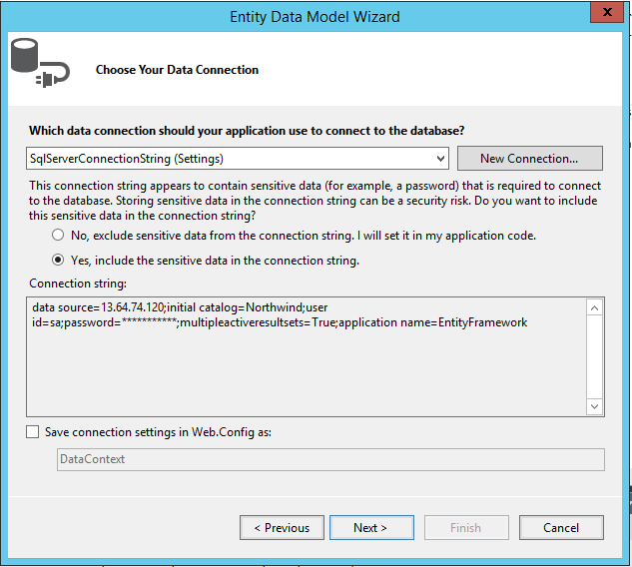
11. Select **Next >**
12. To select database objects to include in the model, expand the **Tables** node and check **NW** only.  
    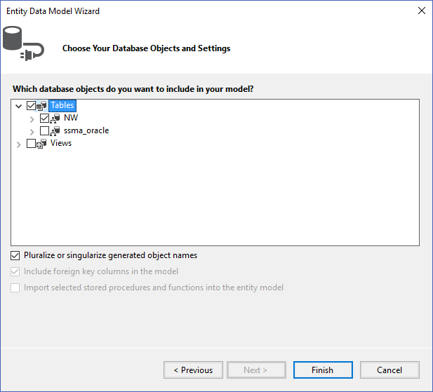
13. Click Finish, and the model will be generated. This may take some time.

### Task 2: Modify Application Code

1. Return to Visual Studio.
2. Open the *DataContext.cs* file in the **Data** folder.
3. The call to base in the DataContext constructor needs to be updated to reflect the correct connection string.   
   Change that line from  
   : base("name=DataContext")  
    to:  
   : base("name=SqlServerConnectionString")
4. Save.
5. Next, open the HomeController.cs file in the Controllers folder.
6. Comment out the code under the Oracle comment, and uncomment the code under the SQL Server comment. There are differences in how stored procedures are accessed in Oracle versus SQL Server.
7. Open the *SALESBYYEAR.cs* in the **Models** folder and change the type of the YEAR property to int.  
   public int YEAR { get; set; }
8. Open the *SalesByYearViewModel.cs* file in the **Models** folder and change the type of the Year property to int.  
   public int Year { get; set; }
9. Run the application.
10. You will get an exception that the stored procedure call has failed. This is because of an error in migrating the stored procedure.
11. To resolve this error, open the *SALES_BY_YEAR_fix.sql* file in the **Solution Items** folder.
12. Make sure the database name on top of the file is correct (within the brackets after the USE keyword).
13. Select the Execute button to run this against your SQL Server version of Northwind, logging in as appropriate.

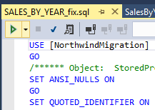

1. Connect to your SQL Server database.  
   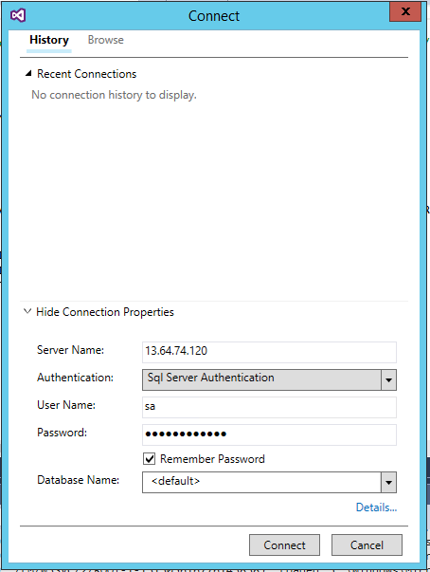
2. Run the application and see the graph is showing correctly.  
   
3. Congratulations, you’ve migrated the data and application from Oracle to SQL Server.

## Exercise 7: Cleanup

Duration: 5 minutes

Synopsis: In this exercise, attendees will de-provision any Azure resources that were created in support of the hackathon.

### Task 1: Clean up Azure Resources

1. Delete the Resource Group(s) containing the SQL Server 2016 VM you created and the Lab Virtual Machine (if you are finished doing hackathons).